Manganese (hydro-)oxideshave received significant attention because of their, potentially dominating, control on Ni ocean concentrations (Peacock and Sherman, 2007a). Hexagonal birnessite is thought to be representative of the poorly crystalline phyllomangates found in the deep ocean. Nickel sorbs as a surface complex and can become structurally incorporated into vacancy sites. Using their sorption complexation model of Ni-bearing hexagonal birnessite, Peacock et al., 2007 calculated the concentration of dissolved Ni in seawater in equilibrium with birnessite to be approximately 7.2 nM at pH 8.2 (Peacock and Sherman, 2007b). This is in good agreement with observed concentrations of Ni in seawater(ca. 3-12 nM) (e.g., Cameron and Vance, 2014; Sclater et al., 1976) and suggests that birnessite, or a similar Mn oxide phase, may be the dominate buffer of seawater Ni concentrations. Our knowledge of Ni’s retention or remobilization, and these processes’ isotopic fractionations, within Mn oxides is becoming increasingly complicated.

Gall et al., 2013 measured 24 surface scrapings of Fe-Mn crusts across the globe and found a variable isotopic range from 0.9 to 2.5‰ with an average of 1.67±0.8‰ (Gall et al., 2013). They did not observe any strong correlation between δ60Ni and ocean basin, oxygen saturation or Ni concentration (Fig xx), but there was a correlation between δ60Ni and distance to continental shelf, likely reflecting the contribution of isotopically lighter continental sediments. This presented the isotopic imbalance and suggested there was no isotopic fractionation associated with Ni sorption on Mn oxides. Gueguen et al., 2016 observed generally similar trends; of the four North and South Pacific Fe-Mn crusts they analyzed, they all generally overlapped with the values found in Gall et al., 2013. (1.79 ± 0.21‰ 2sd, n = 31 for North Pacific and 1.73 ± 0.21‰ 2sd, n = 21 for South Pacific) (Gueguen et al., 2016). In addition, they measured every 1 to 2 mm into the crust for ca. 20 mm and, for three of the cores, there was little isotopic variation down core. One core from the South Pacific had a systematic and dramatic drop in δ60Ni downcore (from 1.89 to 0.25‰) associated with lower Mn/Ni, suggesting that post-depositional processes associated with Mn-oxide phases may lead to alteration of the primary δ60Ni signature. Overall, Fe-Mn crust, and therefore Ni associated with Mn-oxides, appeared to isotopically reflect seawater.

In contrast, Vance et al., 2016 observed light Ni isotopic compositions associated with Mn oxides in water columns sampled within the Black Sea (Vance et al., 2016). Across the oxygen minimum, (i.e., where Mn oxide particles dissolve) the Ni isotopic composition of the water decreased significantly from ca. 1.2 to 0.8‰ while the [Ni] increased which they calculate is associated with an isotopic fractionation of ca. -4‰. They attribute this to Ni sorbed on Mn oxide being released back into the water column upon oxide dissolution at the oxygen minimum. This clearly contradicts the findings of Gueguen et al., 2016 and Gall et al., 2013. A subsequent study measured a mix of hydrogenetic Fe-Mn crusts and hydrothermal Fe-Mn deposits and found both isotopically heavy and light Ni (Gueguen et al., 2020). The hydrogenetic Fe-Mn crusts were isotopically similar to seawater (0.8 to 1.8‰) but hydrothermal deposits have a generally wider, isotopically lighter range (-1.5 to 1.1‰). Finally, Little et al., 2020 analyzed the Ni isotopic composition of Mn rich crusts in the Eastern Pacific, where measured Fe-Mn crust samples in that region were +1.6‰, and predominately found isotopically light sediments (−0.8 to −0.2‰) (Little et al., 2020).

A number of mechanisms have been evoked to explain these variations. Vance et al., 2016

Experiments exploring Ni sorption and/or incorporation into Fe oxides and Mn oxides have indicated that the solid will sorb and/or incorporate isotopically light Ni relative to solution (Gueguen et al., 2018; Sorensen et al., 2020; Wasylenki et al., 2019, 2015). Sorption onto Fe oxides such as ferrihydrite and goethite have moderate fractionations of Δ60/58Nimineral-aqueous = -0.35 ± 0.08‰ (2sd) and Δ60/58Nimineral-aqueous = -0.77 ± 0.23‰ (2sd), respectively (Gueguen et al., 2018). Nickel sorption onto birnessite appears to have a surprisingly large fractionation factor, considering there is no change in coordination environment or valence. Low ionic strength, 24h benchtop sorption experiments measured Δ60/58Nimineral-aqueous values from −2.76‰ to −3.35‰ depending on pH (Sorensen et al., 2020). They attributed the range to differing proportions of incorporated and sorbed Ni (Fig. XX). These values cannot explain the isotopically heavy Fe-Mn crust values found, but roughly corroborate the isotopically light Ni associated with manganese oxide dissolution in the black sea.

What about high ionic strength solutions? Perhaps the high salinity in seawater has an important effect on Δ60/58Nimineral-aqueous as it does for other isotopic systems (Horner et al., 2011; Wasylenki et al., 2014; Dong and Wasylenki, 2016). High ionic strength experiments allowed to equilibrate for 67 hours had a Δ60/58Niaqueous-sorbed up to ~4.0‰ (Wasylenki et al., 2019) which exactly matches the calculated Ni isotope fractionation from Mn oxide dissolution in the Black Sea water column (Vance et al., 2016). However, Wasylenki et al., 2019 observed decreasing fractionation factors in longer duration (ca. 1 month) experiments which suggests shorter experiments may have recorded a short-lived kinetic fractionation while longer experiments (27 days) overwrite the initial kinetic effects.

Can the natural and experimental results be reconciled? Some argue yes, but there appear to be significant gaps in the reasoning. [talk about Mn redox cycling, little argument, available reasonings for Fe-Mn crust that don’t make too much sense. Crescendo to “maybe Vance et al recorded kinetic processes, but Fe-Mn crust are equilibrium. What is that equlibirum? Then the variability can be explained by birnessite to todorkite transformation.]

Reconciling the natural and experimental data is quiet challenging.

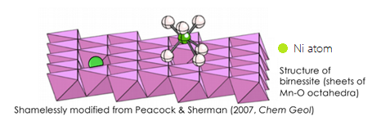

**Figure :** A depiction of the two coordination states of Ni and birnessite, incorporated and sorbed. Figure from Wasylenki et al., 2019 which was adapted from Peacock & Sherman 2007.

**Figure 3: δ60Ni in four Fe-Mn crust cross sections from the South and North Pacific Ocean.** The ZEP2 Fe-Mn crusts are South Pacific and J2 crusts are North Pacific. The anomalous isotopically light values of ZEP2-DR-05-04 are attributed to post depositional effects (Gueguen et al., 2016).

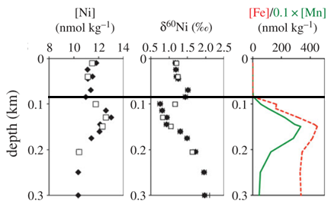**Figure 4: Comparing δ60Ni and the concentrations of Fe, Mn, and Ni in the upper 300 m of the Black Sea.** The black, horizontal line generally denotes the chemocline (Vance et al., 2016)

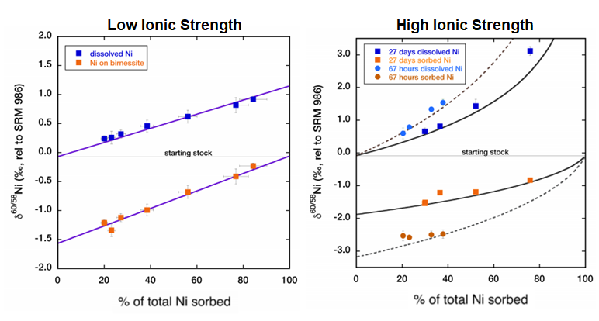

**Figure 6: Graphs of the low and high ionic strength experiments performed by Wasylenki et al., 2019.**

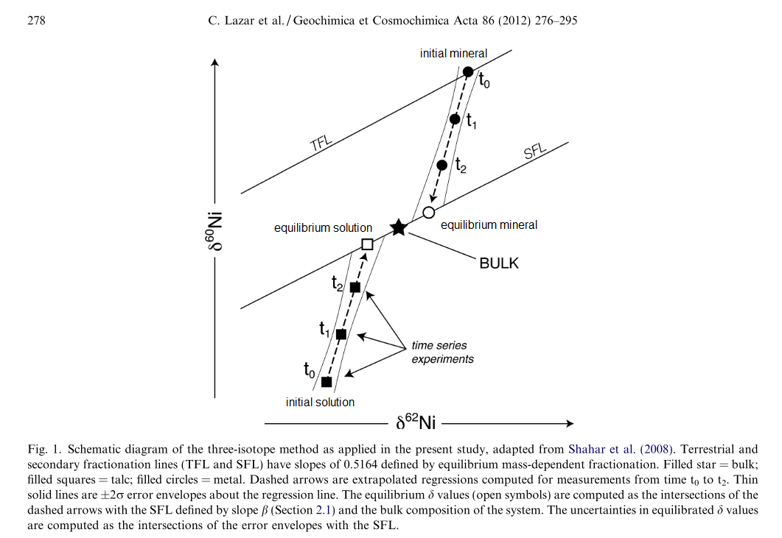

**Figure 7: Diagram of the three-isotope method.** The filled in black symbols represent measured values while the empty symbols are extrapolated based on best fit lines. The star represents the isotopic composition of the system. Figure adapted from Lazar et al., 2012.

$$β=\frac{\frac{1}{m_{58}}-\frac{1}{m_{60}}}{\frac{1}{m_{58}}-\frac{1}{m_{62}}}$$

Equation 3